I’ve selected a photo of my PC, a direct front facing version, though I’ve taken a bit of angled shot (it weighs 180 lbs so moving it is not easy). 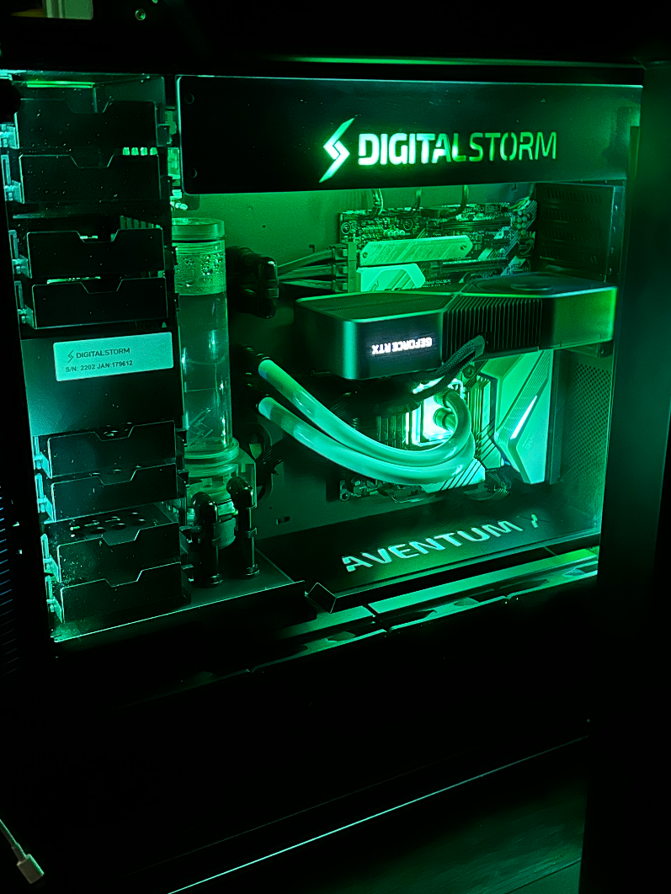

Shapes to replicate:

Cylinder: the cooling reservoir, coolant inside reservoir.

Plane: Motherboard, tempered glass cover

Box: Computer case, the GPU, Fan case, HDD Column, metal piping

Undecided/Unsure: Cooling hoses.

Computers are a vast and technologically dense system. I could take a motherboard alone and spend ages converting it into a 3D shape, but it would be immensely tedious. Instead for the purposes of learning to design intelligently, I’ll take this 2D image and convert elements of it into a rudimentary 3D representation that to the viewing party, would (hopefully) be identifiable as the internals of a desktop computer.